Silhouette metric for img011001.jpg is: 0.9796540942392157

Davies Bouldin metric for img011001.jpg is: 0.02767522580879675

Calinski Harabasz metric for img011001.jpg is: 901332.8070951201

ID 0: (1736, 445)

ID 1: (1087, 177)

ID 2: (915, 413)

ID 3: (965, 291)

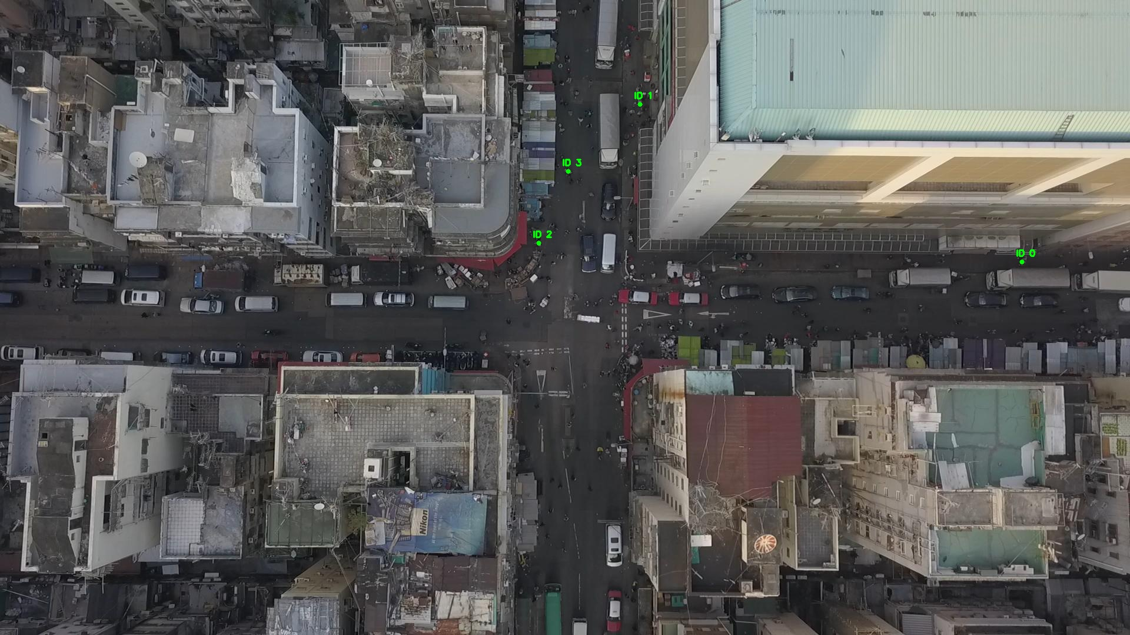

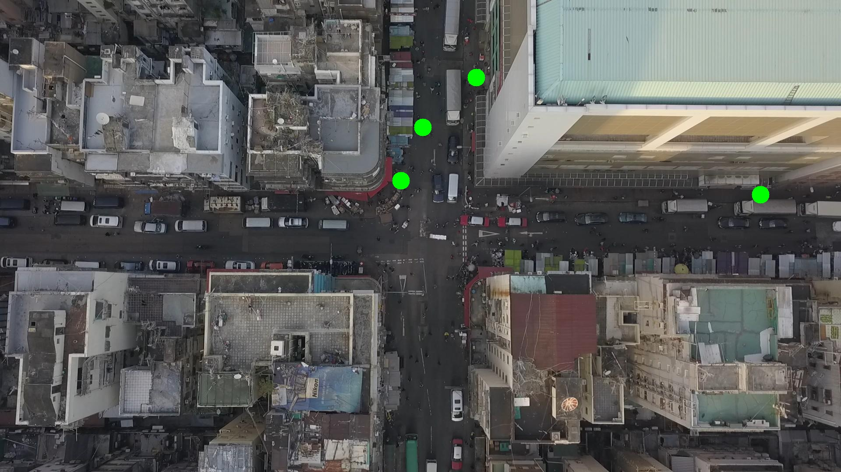

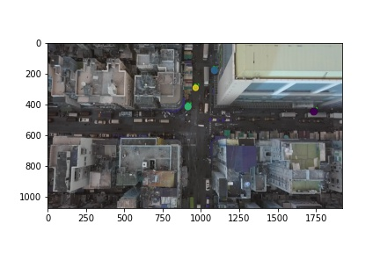

Silhouette metric for img011002.jpg is: 0.9013541217343254

Davies Bouldin metric for img011002.jpg is: 0.11943068229094016

Calinski Harabasz metric for img011002.jpg is: 8120.136763454029

ID 0: (1142, 557)

ID 1: (1087, 178)

ID 2: (889, 440)

ID 3: (997, 193)

ID 4: (937, 815)

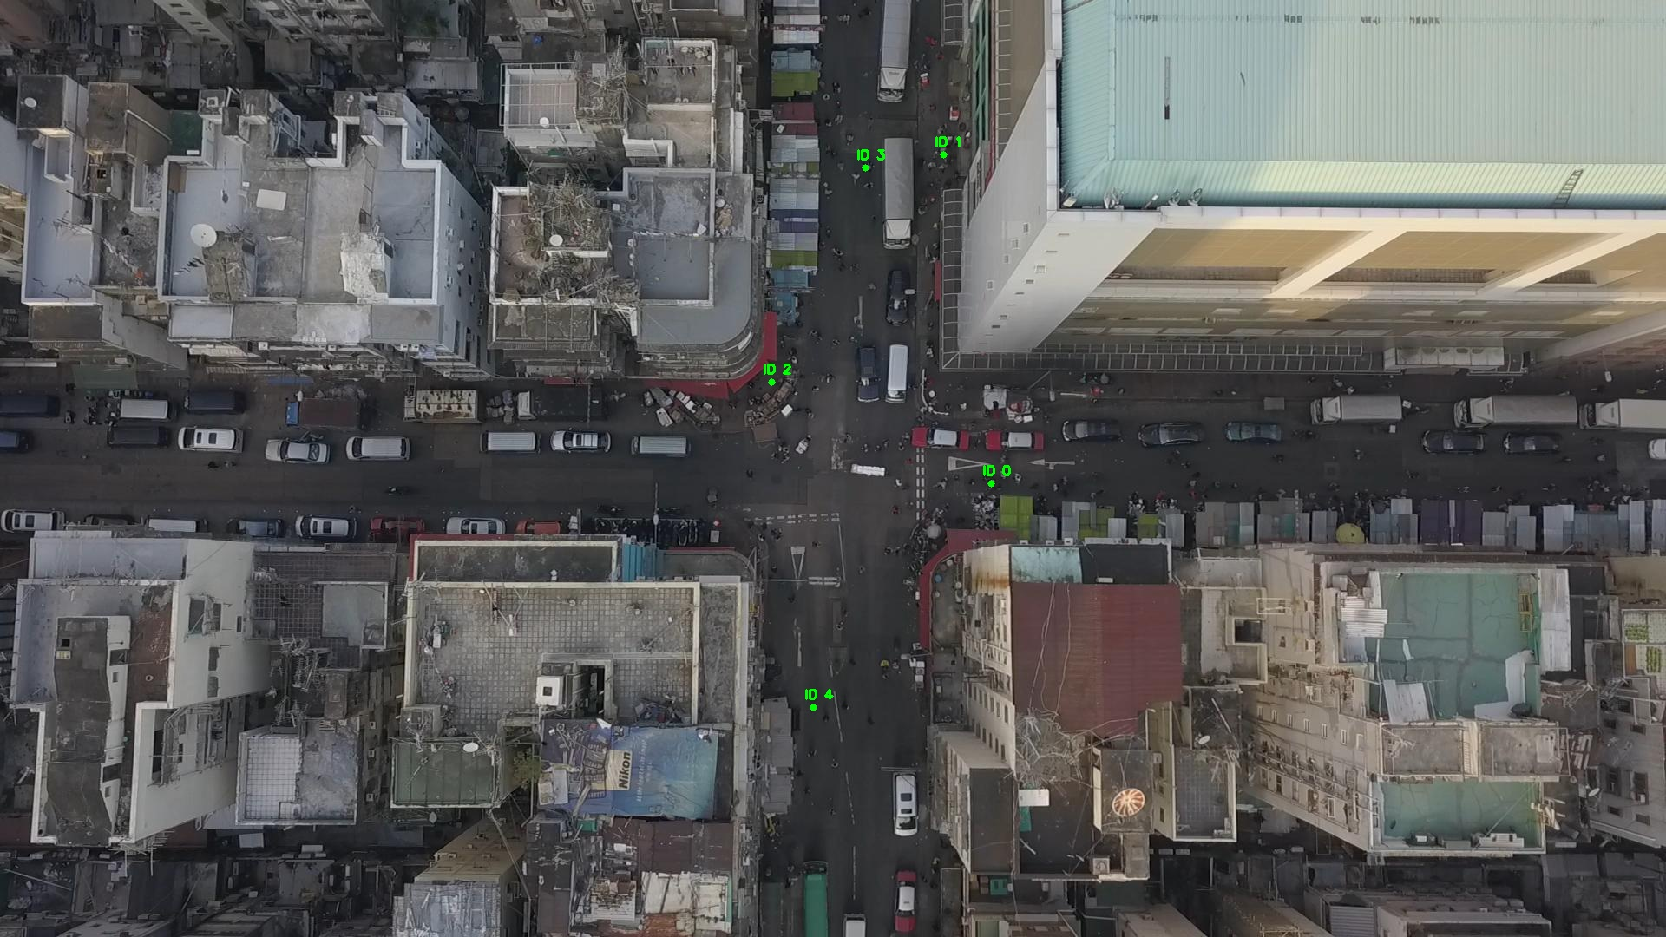

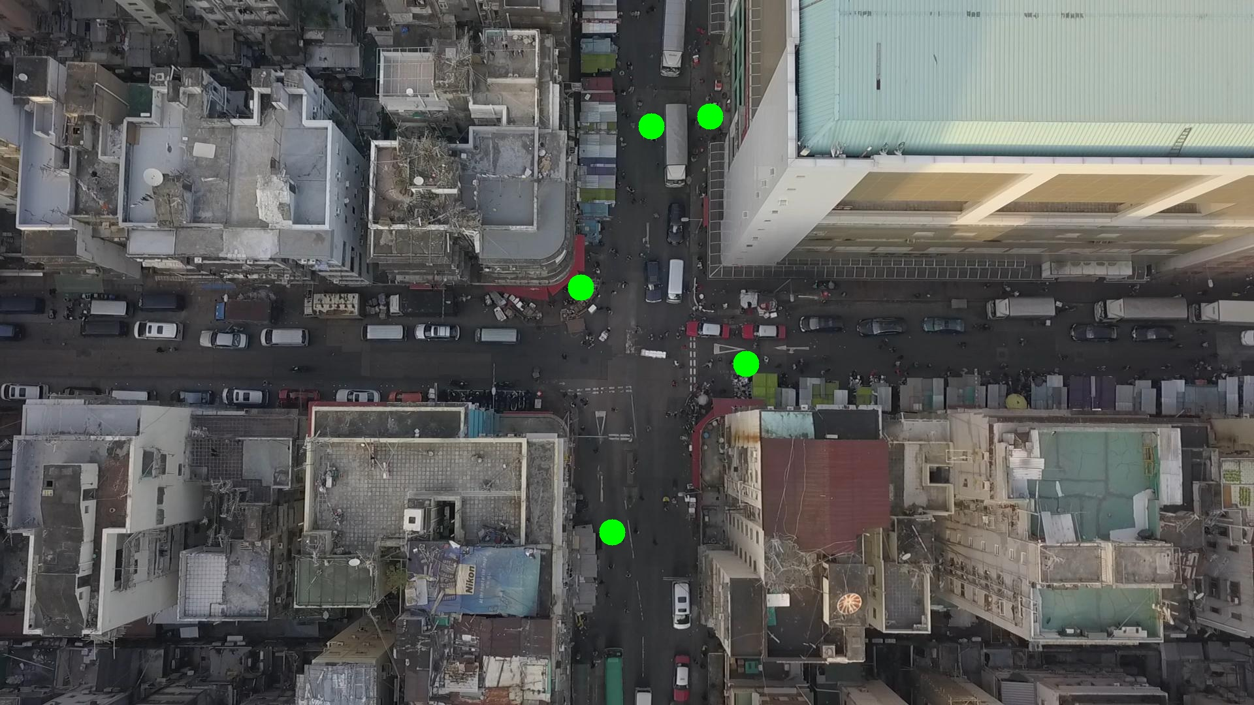

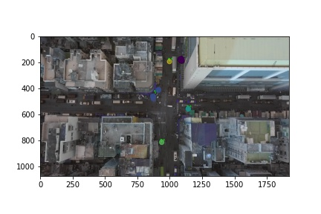

Silhouette metric for img011003.jpg is: 0.8966621870893718

Davies Bouldin metric for img011003.jpg is: 0.14963043730004583

Calinski Harabasz metric for img011003.jpg is: 11447.204827087351

ID 0: (1142, 557)

ID 1: (1087, 178)

ID 2: (892, 436)

ID 3: (997, 193)

ID 4: (937, 815)

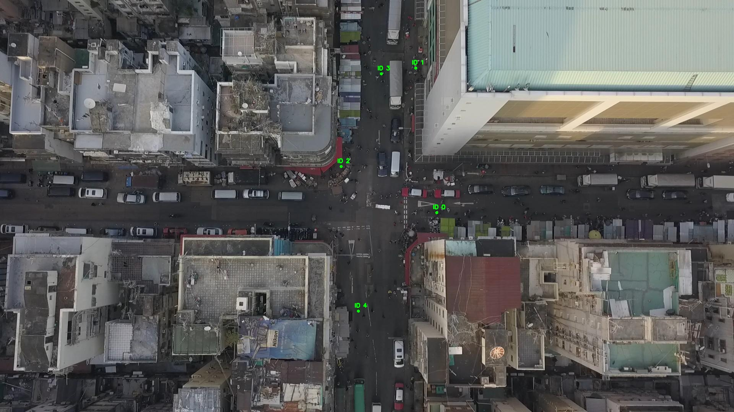

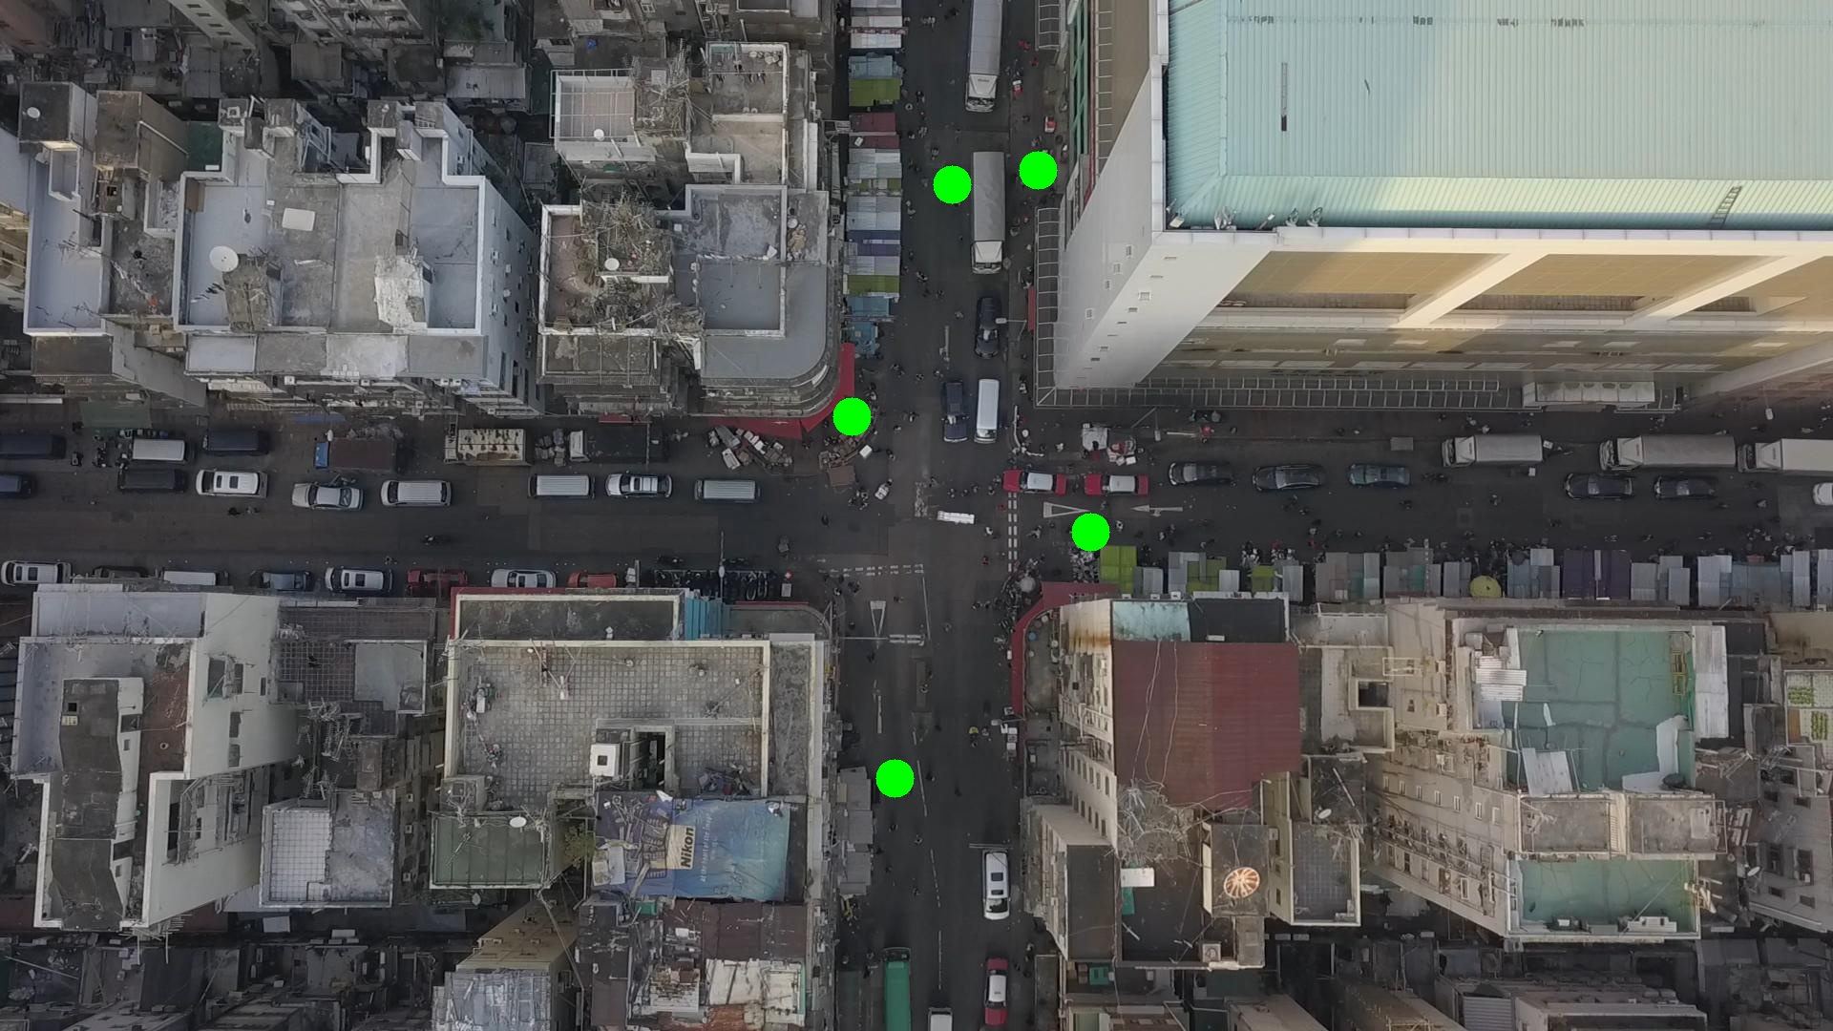

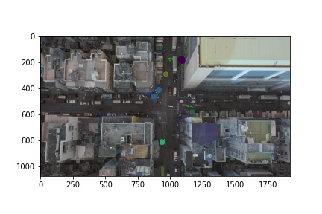

Silhouette metric for img011004.jpg is: 0.881119622029327

Davies Bouldin metric for img011004.jpg is: 0.17155207861661687

Calinski Harabasz metric for img011004.jpg is: 5342.779099694888

ID 0: (1142, 557)

ID 1: (1087, 180)

ID 2: (889, 439)

ID 3: (997, 193)

ID 4: (937, 815)

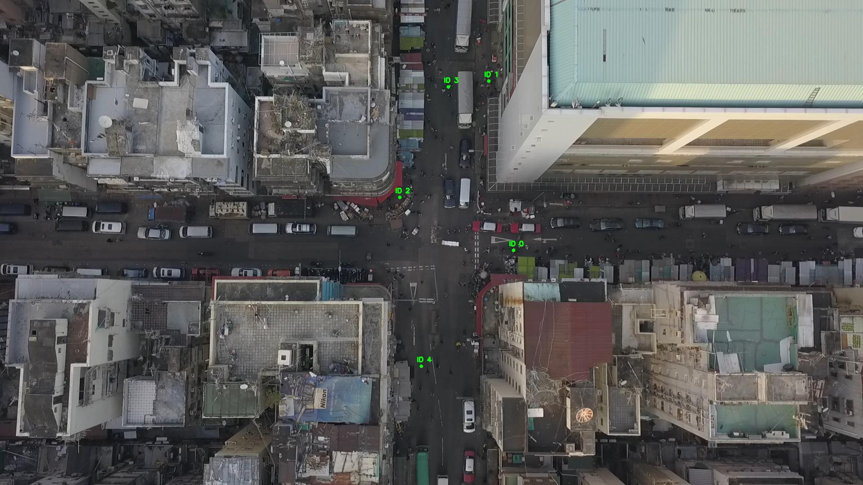

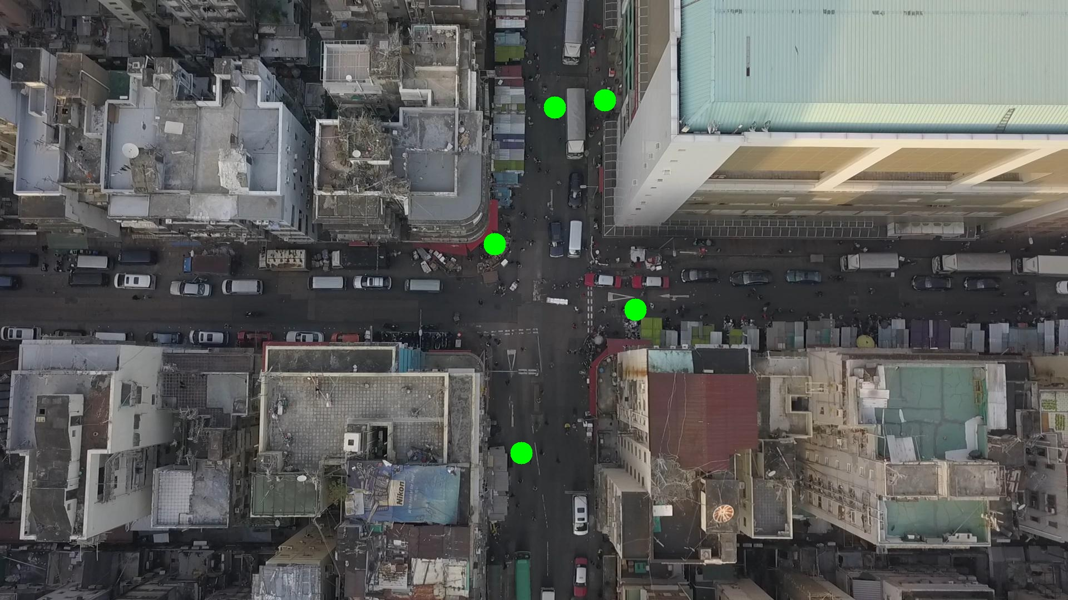

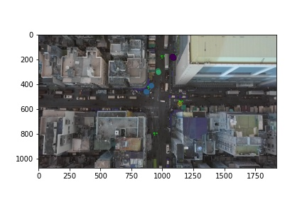

Silhouette metric for img011005.jpg is: 0.7048013521415465

Davies Bouldin metric for img011005.jpg is: 0.31586980902960415

Calinski Harabasz metric for img011005.jpg is: 15411.452723233155

ID 0: (1112, 575)

ID 1: (1083, 181)

ID 2: (949, 334)

ID 3: (996, 192)

ID 4: (937, 813)

ID 5: (1376, 554)

ID 6: (891, 654)

ID 7: (96, 478)

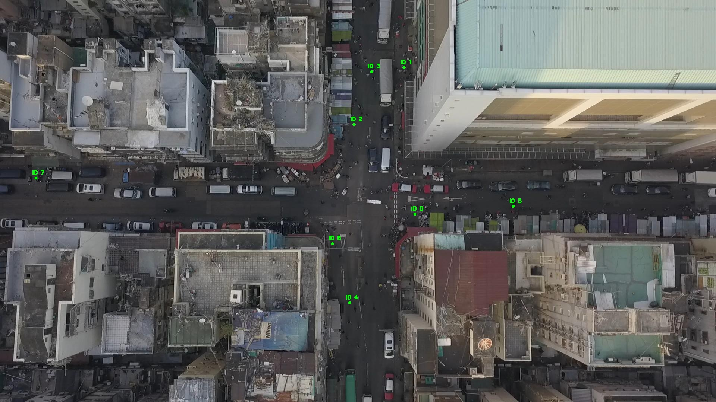

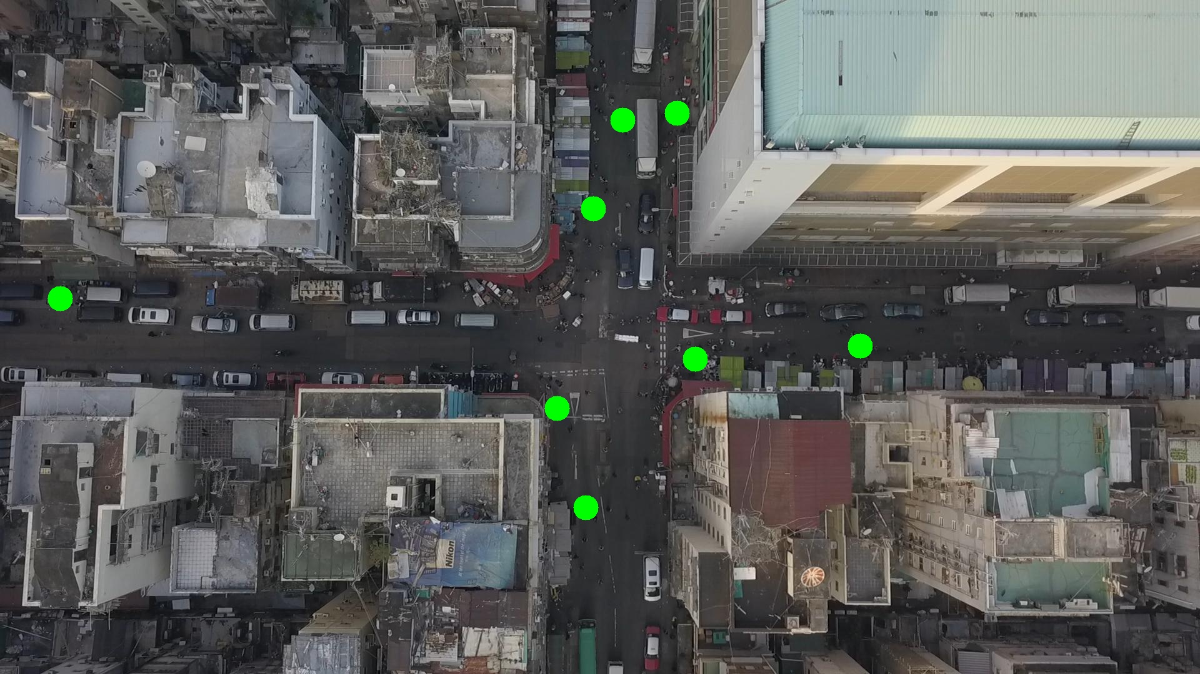

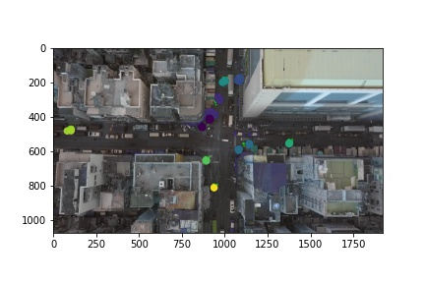

Silhouette metric for img011006.jpg is: 0.651726297078966

Davies Bouldin metric for img011006.jpg is: 0.28077822059787366

Calinski Harabasz metric for img011006.jpg is: 29594.206735354484

ID 0: (1128, 577)

ID 1: (1083, 181)

ID 2: (951, 331)

ID 3: (1039, 188)

ID 4: (937, 811)

ID 5: (1366, 544)

ID 6: (891, 654)

ID 7: (97, 477)

ID 8: (930, 906)

ID 9: (906, 415)

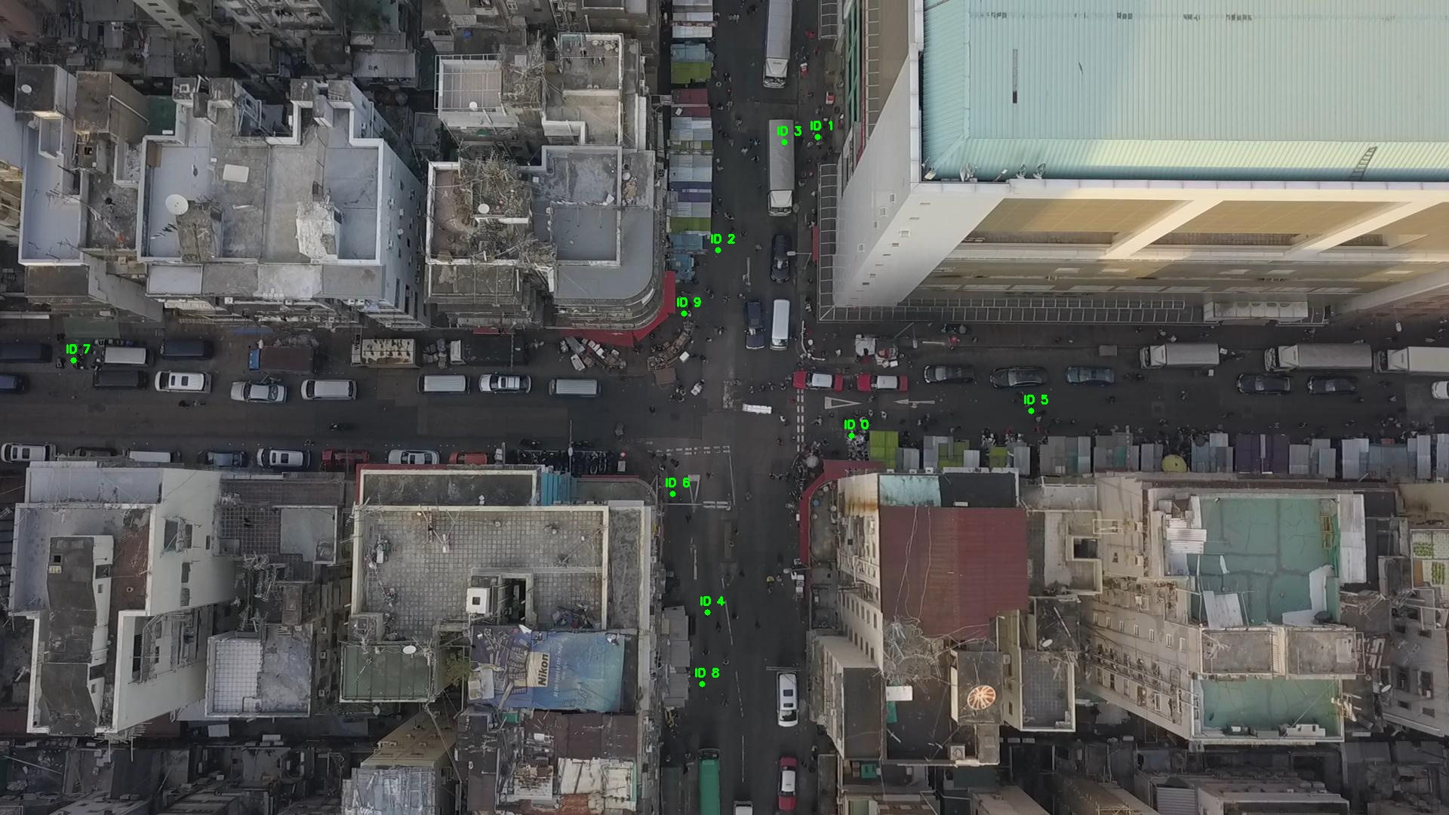

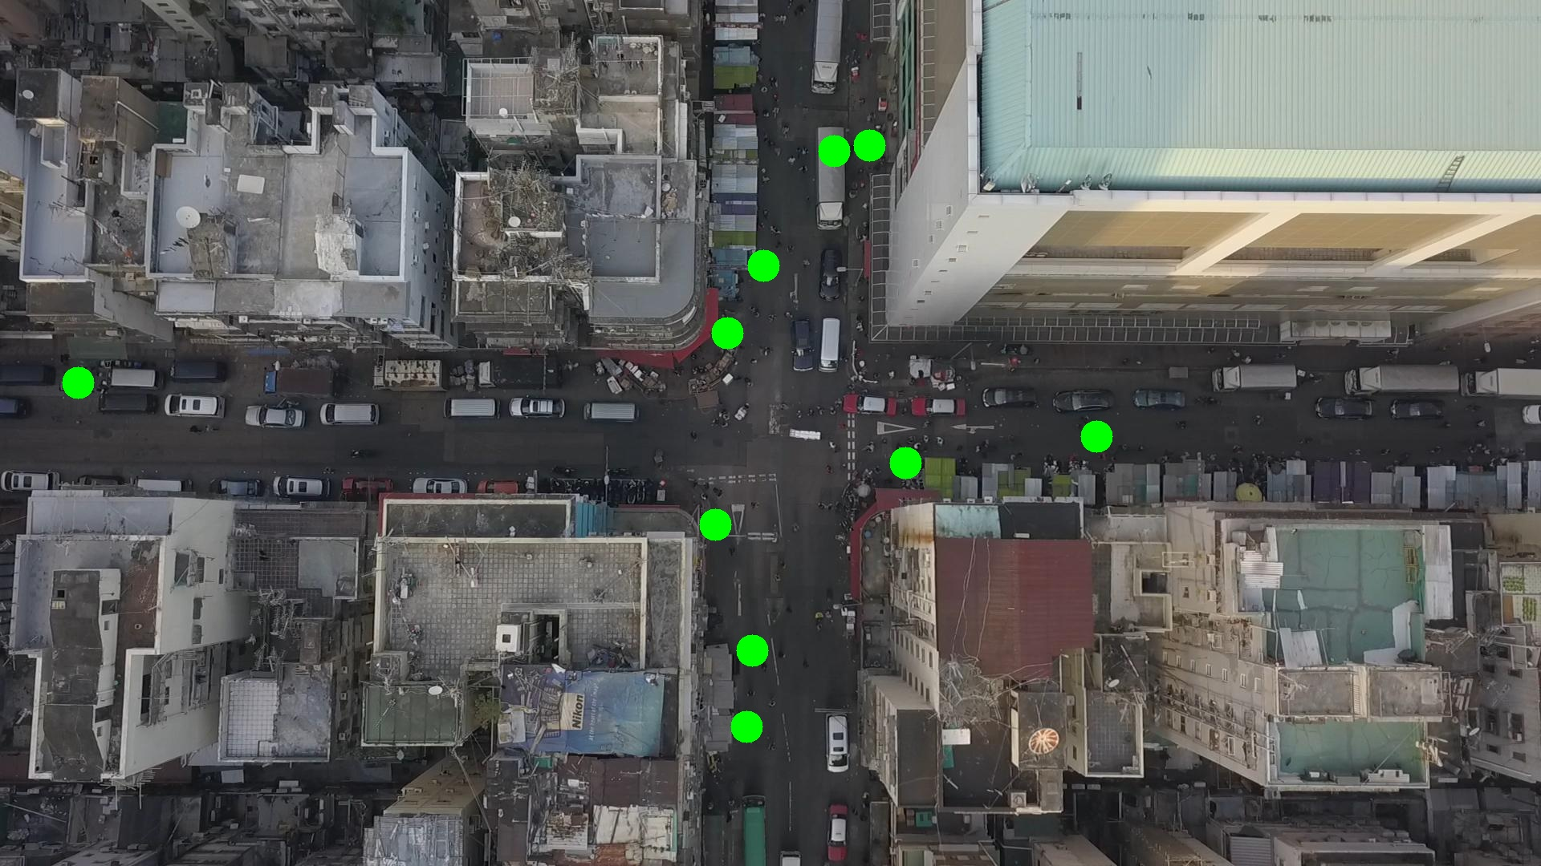

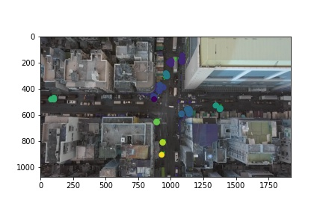

Silhouette metric for img011007.jpg is: 0.6559342115770457

Davies Bouldin metric for img011007.jpg is: 0.32446903614949407

Calinski Harabasz metric for img011007.jpg is: 22459.280300141625

ID 0: (1118, 579)

ID 1: (1083, 181)

ID 2: (947, 336)

ID 3: (1045, 186)

ID 4: (937, 811)

ID 5: (1377, 553)

ID 6: (891, 654)

ID 7: (92, 477)

ID 8: (930, 906)

ID 9: (890, 494)

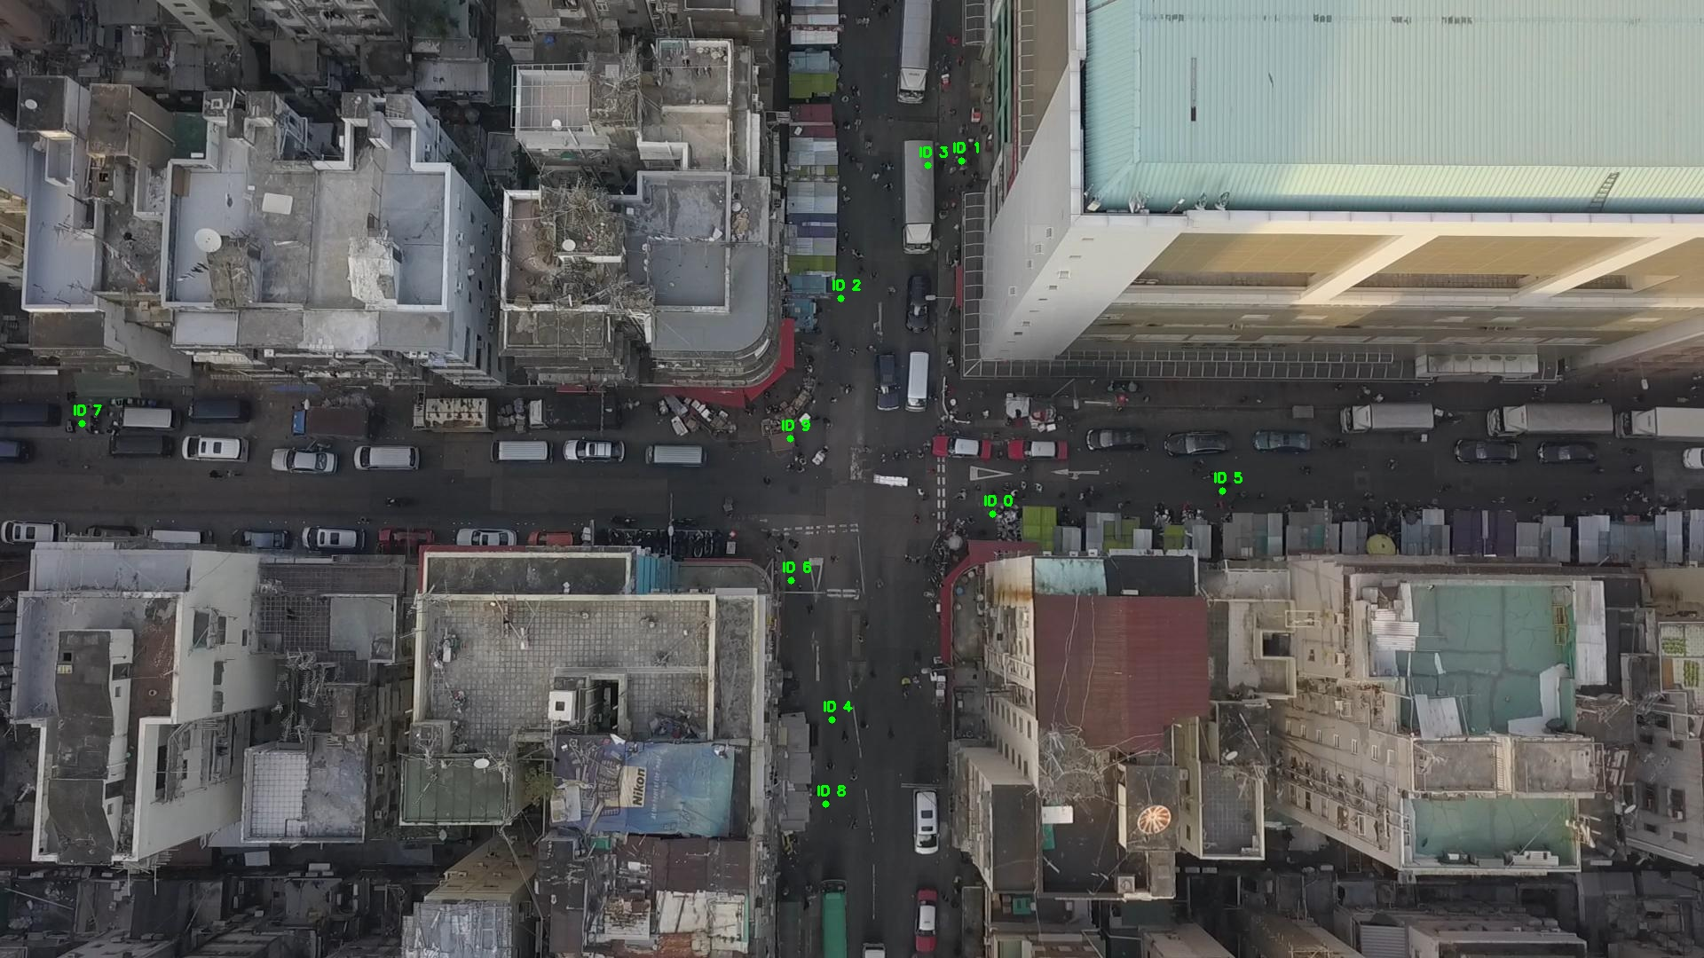

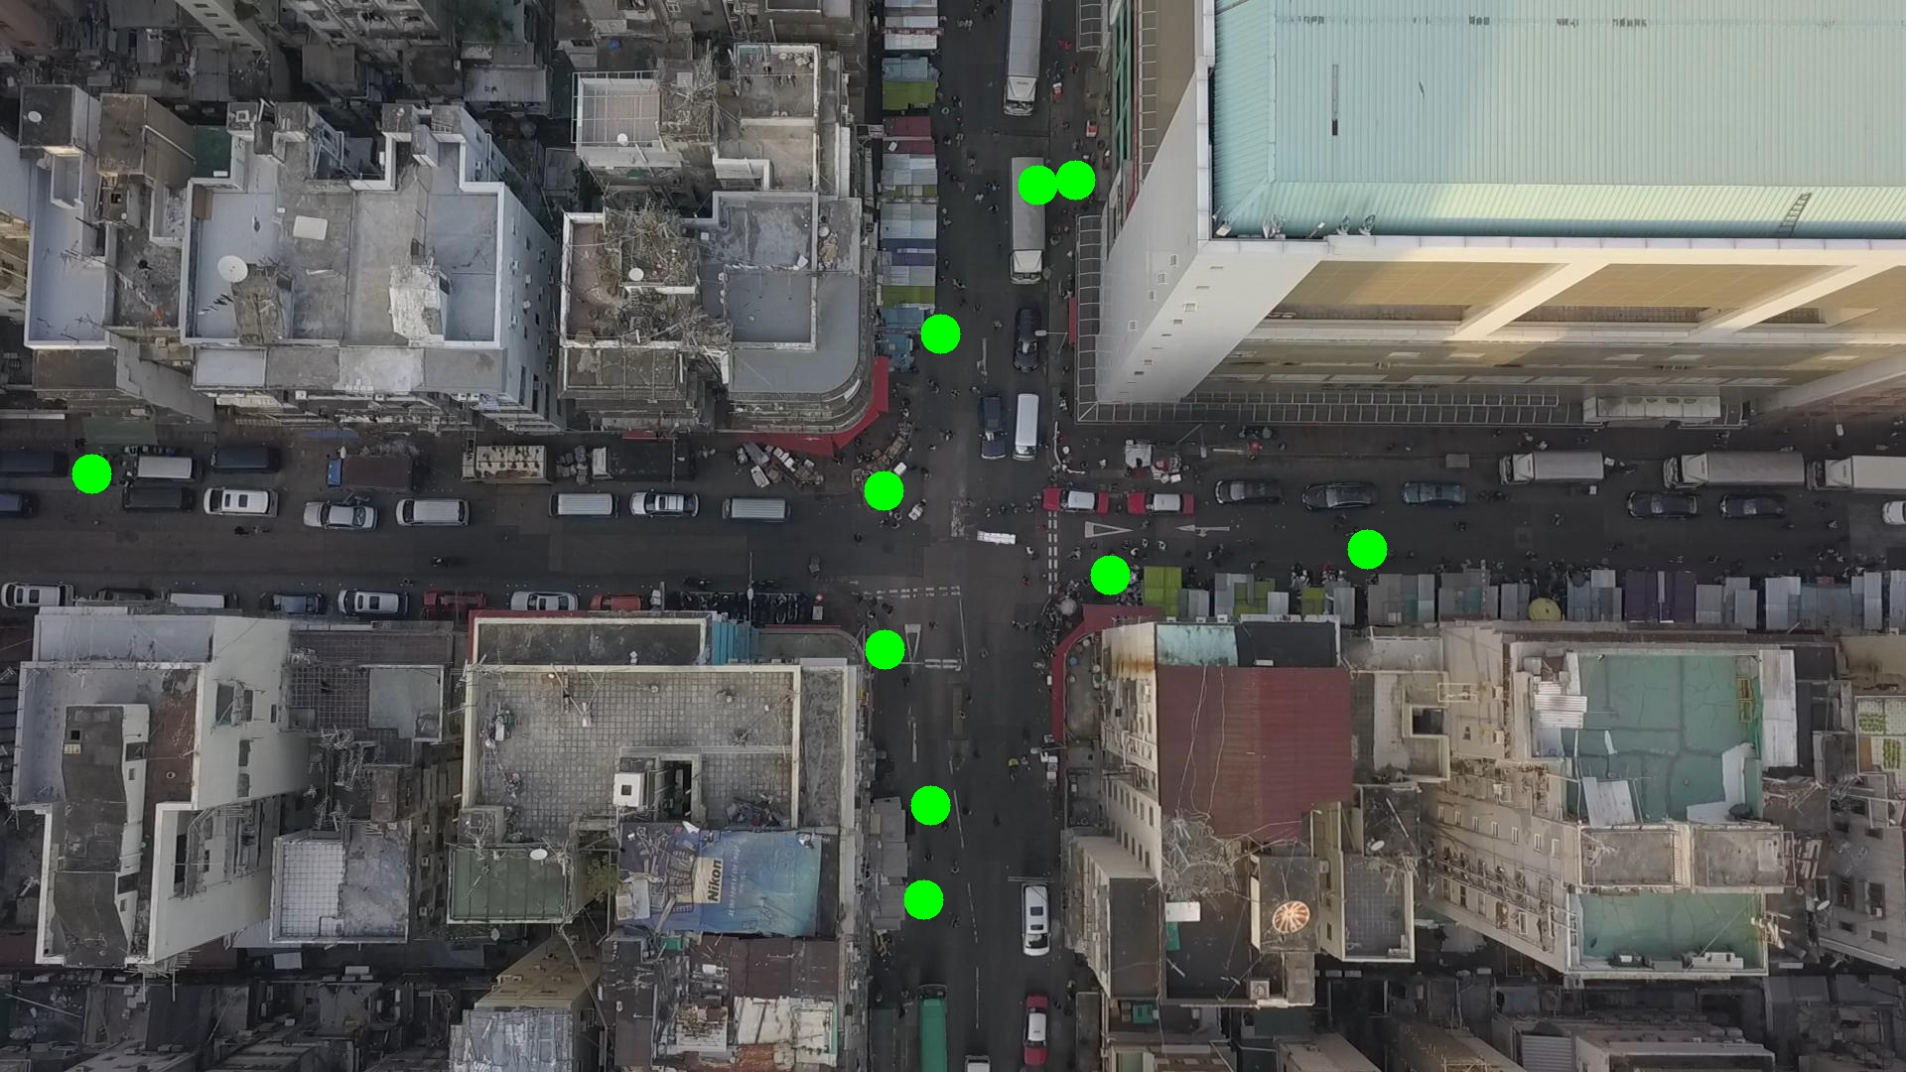

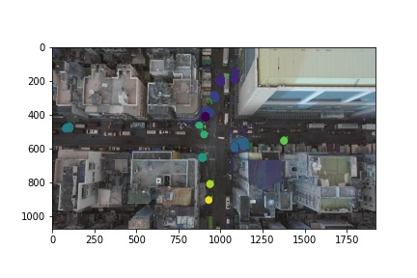

Silhouette metric for img011008.jpg is: 0.8242074719189739

Davies Bouldin metric for img011008.jpg is: 0.1840658799670541

Calinski Harabasz metric for img011008.jpg is: 65641.95641786112

ID 0: (1121, 578)

ID 1: (1081, 180)

ID 2: (967, 291)

ID 3: (1045, 186)

ID 4: (937, 811)

ID 5: (1377, 553)

ID 6: (891, 653)

ID 7: (89, 478)

ID 8: (930, 904)

ID 9: (899, 518)

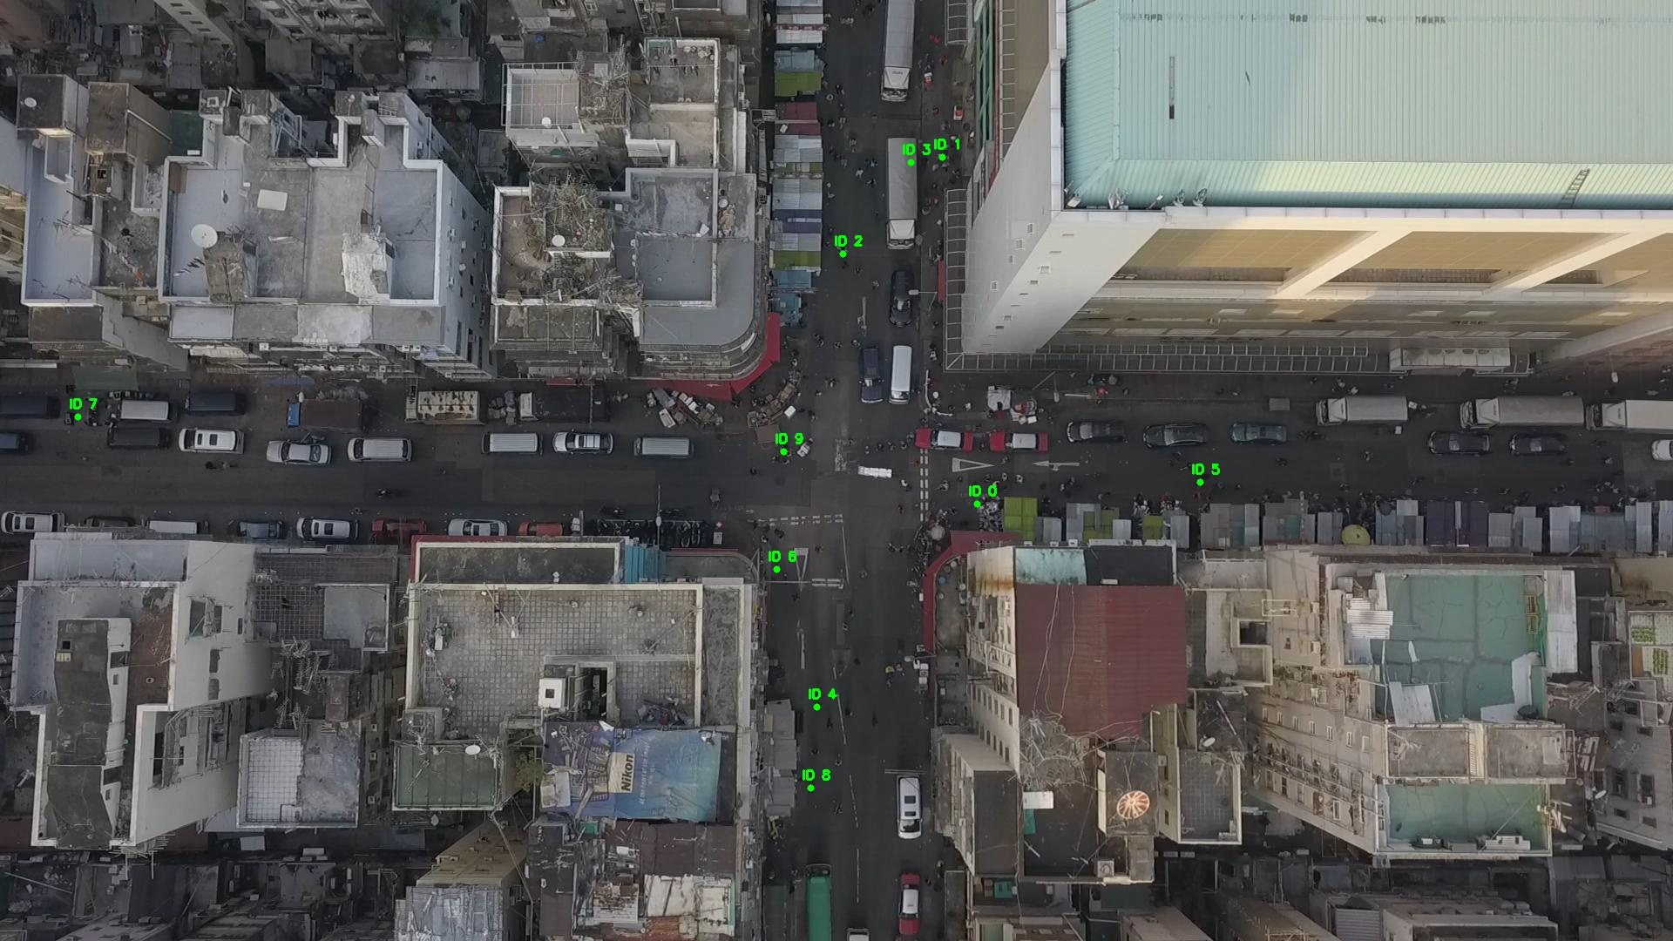

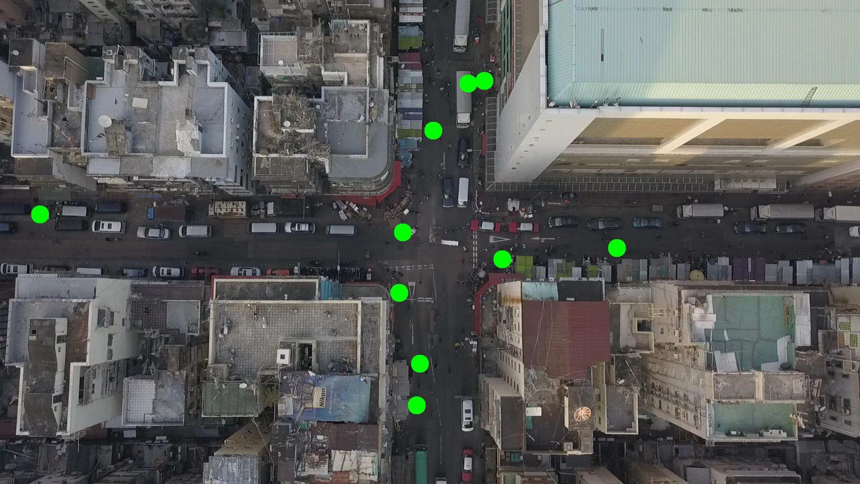

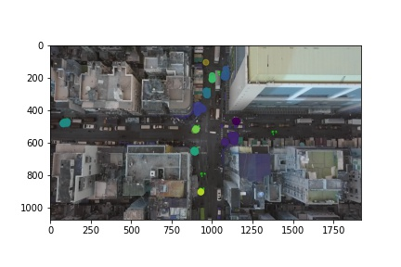

Silhouette metric for img011009.jpg is: 0.8547363569825035

Davies Bouldin metric for img011009.jpg is: 0.17896346234955704

Calinski Harabasz metric for img011009.jpg is: 89123.83499997313

ID 0: (1130, 581)

ID 1: (1079, 186)

ID 2: (964, 288)

ID 3: (1045, 186)

ID 4: (937, 811)

ID 5: (1377, 553)

ID 6: (891, 653)

ID 7: (96, 476)

ID 8: (1065, 1012)

ID 9: (892, 525)

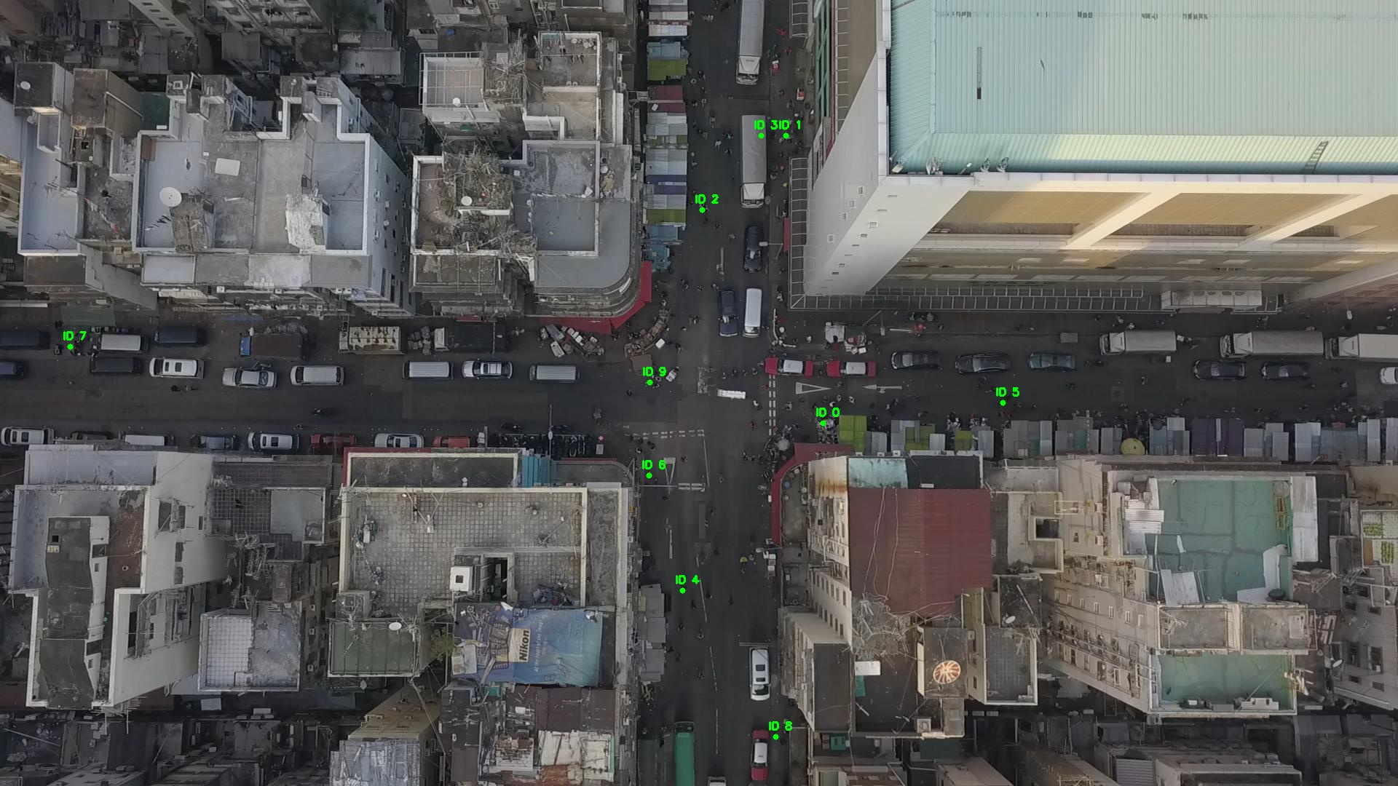

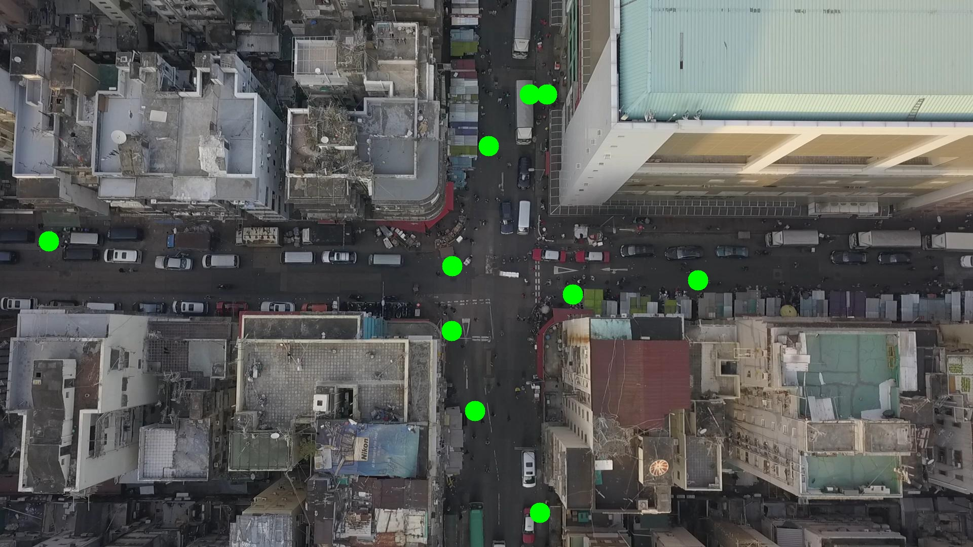

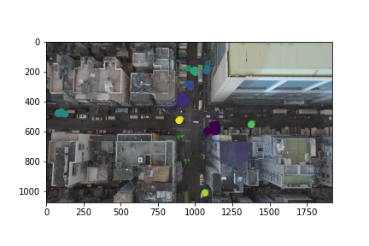

Silhouette metric for img011010.jpg is: 0.8177510779745099

Davies Bouldin metric for img011010.jpg is: 0.17523978387749456

Calinski Harabasz metric for img011010.jpg is: 34107.70418442519

ID 0: (1127, 582)

ID 1: (1079, 186)

ID 2: (967, 290)

ID 3: (1049, 182)

ID 4: (937, 811)

ID 5: (1378, 551)

ID 6: (892, 652)

ID 7: (86, 478)

ID 8: (1065, 1011)

ID 9: (894, 526)

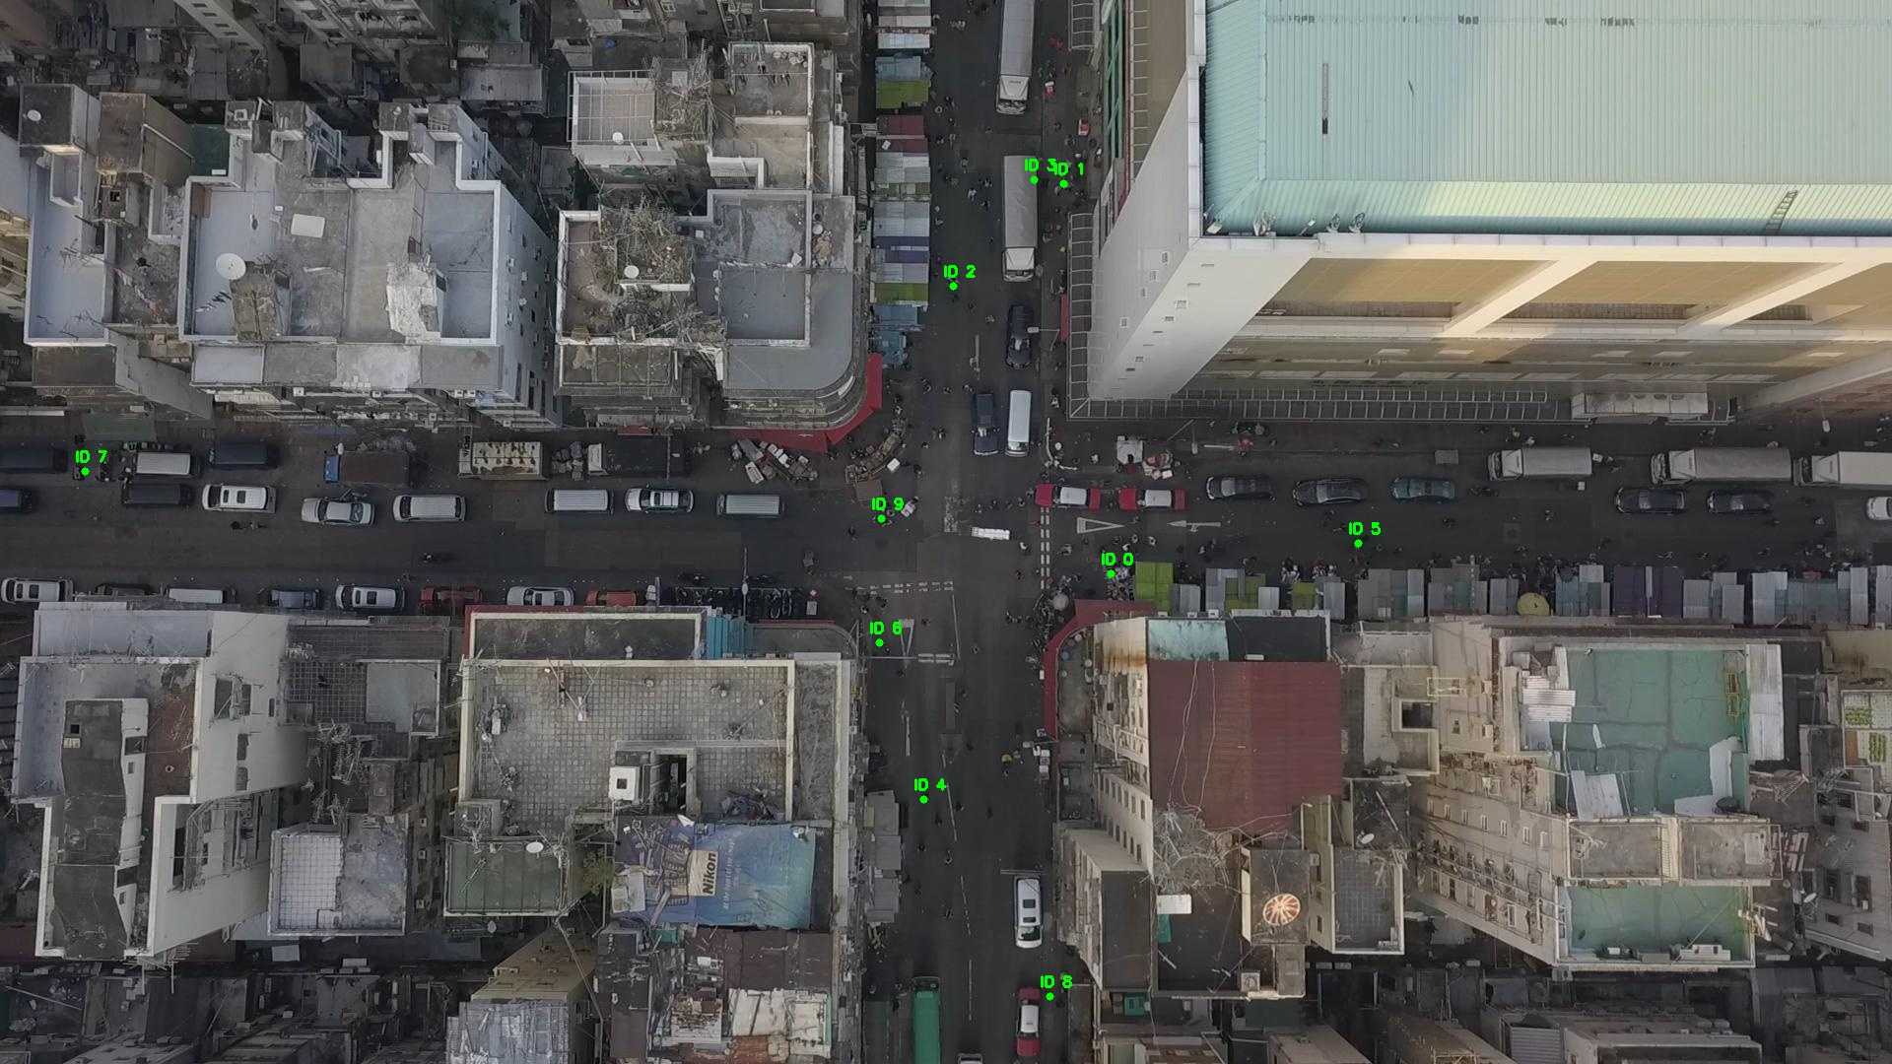

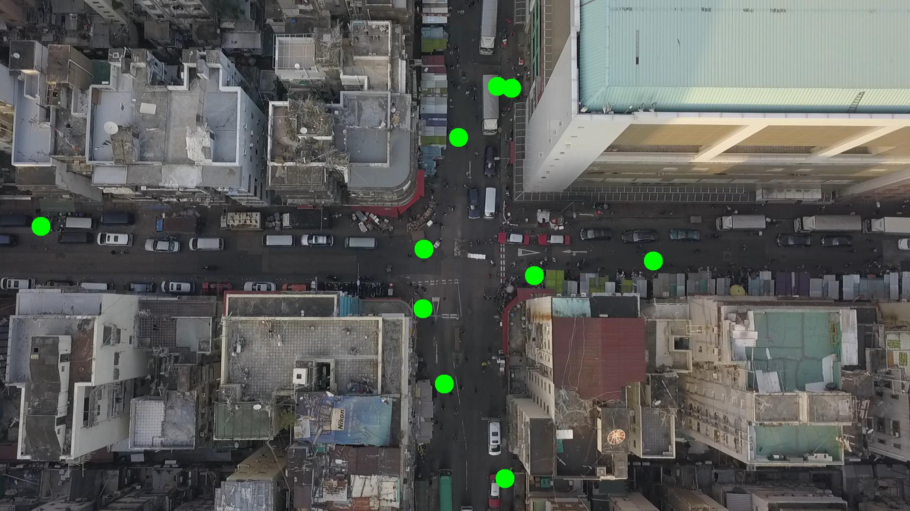

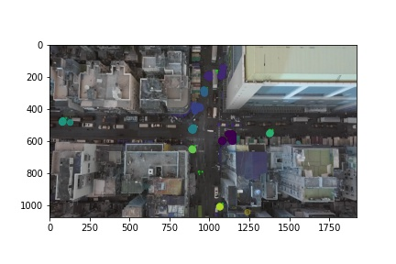

Silhouette metric for img011011.jpg is: 0.8201083558378798

Davies Bouldin metric for img011011.jpg is: 0.16251656703330844

Calinski Harabasz metric for img011011.jpg is: 58971.362322586574

ID 0: (1130, 580)

ID 1: (1078, 179)

ID 2: (964, 288)

ID 3: (1049, 182)

ID 4: (949, 830)

ID 5: (1378, 551)

ID 6: (891, 650)

ID 7: (87, 479)

ID 8: (1066, 1012)

ID 9: (894, 527)

ID 10: (917, 389)

ID 11: (932, 905)

ID 12: (1265, 569)

ID 13: (993, 187)

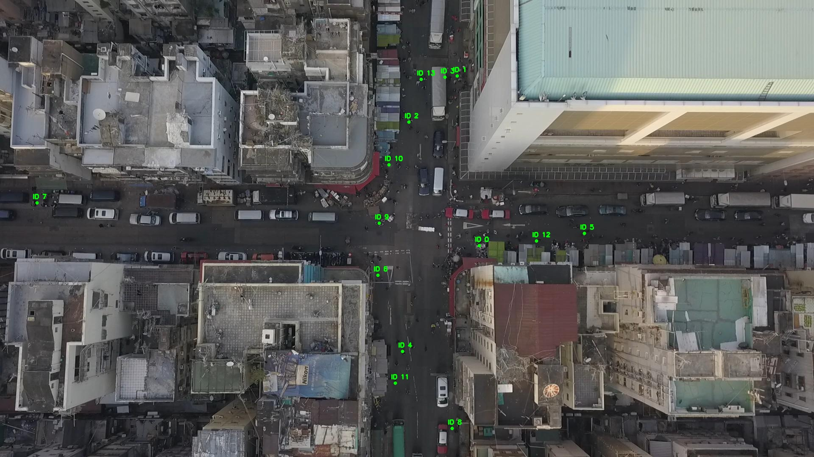

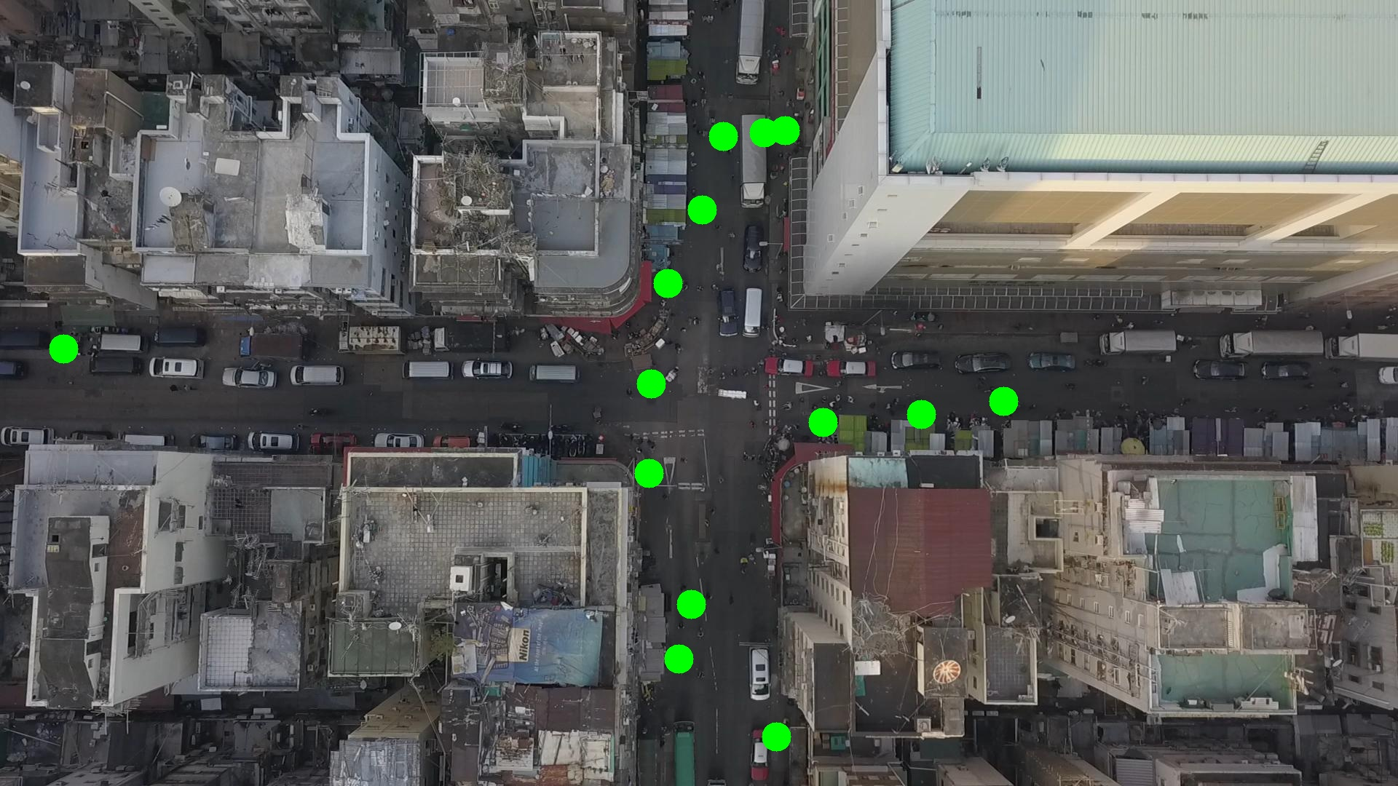

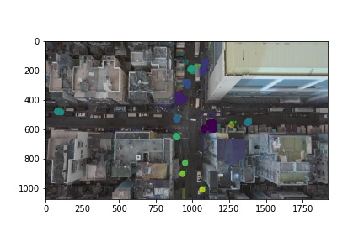

Silhouette metric for img011012.jpg is: 0.6929038230255955

Davies Bouldin metric for img011012.jpg is: 0.23667049838306678

Calinski Harabasz metric for img011012.jpg is: 31565.04521369166

ID 0: (1128, 582)

ID 1: (1078, 179)

ID 2: (965, 284)

ID 3: (1052, 181)

ID 4: (949, 830)

ID 5: (1372, 543)

ID 6: (890, 650)

ID 7: (83, 479)

ID 8: (1065, 1011)

ID 9: (889, 526)

ID 10: (924, 391)

ID 11: (932, 905)

ID 12: (1265, 569)

ID 13: (993, 187)

